Lab #4

Design Patterns Lab

Mukul Ambulgekar

Student Id- 009991254

**Class Diagram:-**

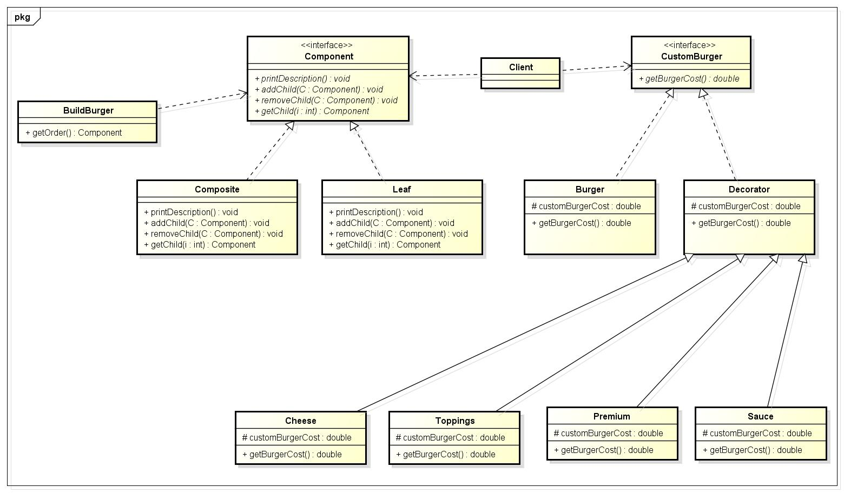

**Sample Output:-**

